**Snapshot:**

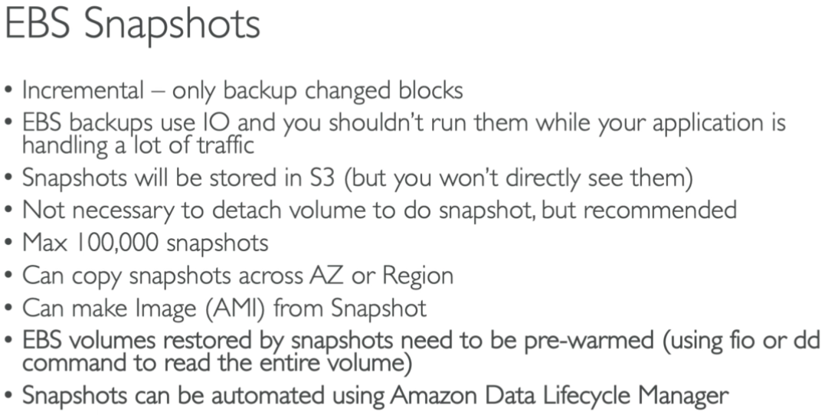

* Snapshot is used to take up to certain stage of volume
* We can make scripts to take snapshots

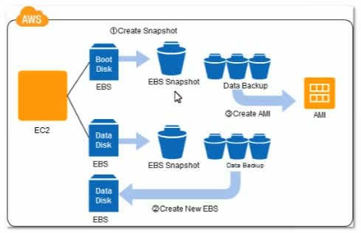

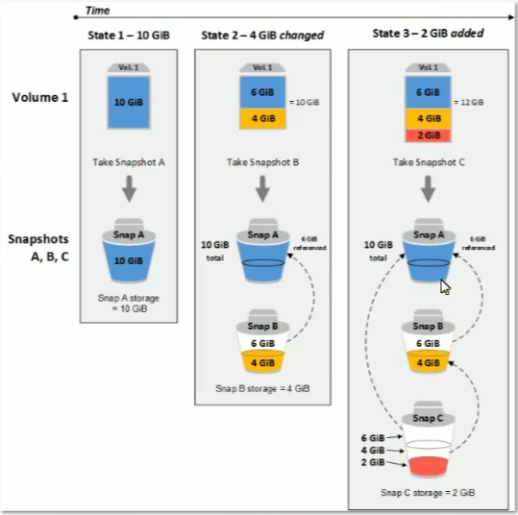

* Snapshots will be like incremental
* As above, snap B refers to snap A and snap C refers to snap B
* It will take the changed data only when we take snapshot
* Either we can create a snapshot and push it to the instance later or we can create an AMI from the instance and use it later

**Creating Snapshot:**

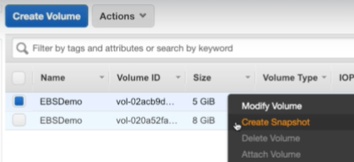

* Right click on the volume and select create snapshot.

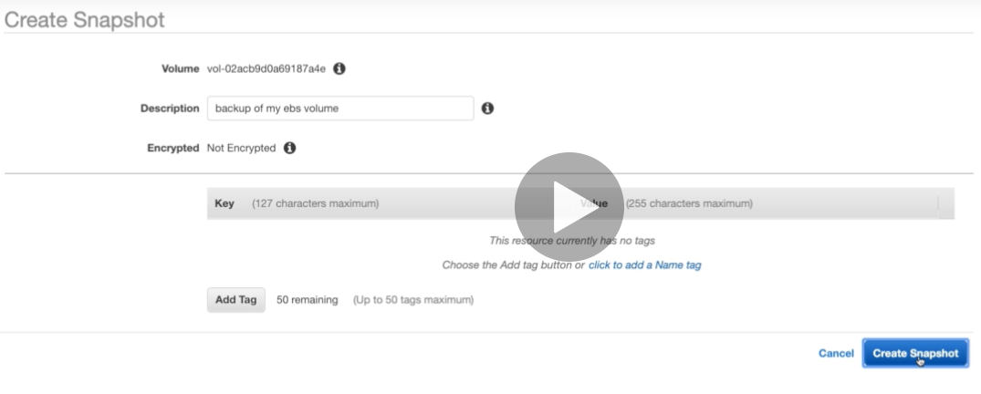

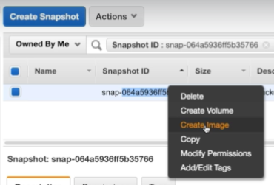

* Once the snapshot is created. We can delete that, create another EBS volume from it or we can create image out of it.
* We can copy it to different region also.
* If we want to modify the hard disk on fly if there is data in it until the OS supports to the operation
* Magnetic is actually HDD
* If we want to move the data to magnetic or some other type. We need to take backup and move the data manually
* If we want to decrease the size, create a new volume and move the data to new volume
* If the original disk is encrypted, then the snapshots will also be encrypted. Otherwise not
* With the snapshot, we take backup of the disk
* We cannot take backup of few files or restore selected files. We can take entire backup

**Snapshots are incremental. It takes the backup of only written blocks. But the snapshot size it would show same as the volume size. But it actually takes only the written data from the volume.**

**If the snapshot size is 10 GB. Then the default size of the volume which we create out of it will also be 10 GB. We can increase it. But we can’t decrease it.**

**We cannot create the snapshot or create the image with lesser memory than current volume size**

**We cannot attach the volumes to the instances which are in other regions**

**Even after registering the AMI, the snapshots will be there which are related to those AMIs**

**Even if the snapshot is incremental, we can still delete the referred snapshot**

**We cannot detach root volume from the instance while running. We can detach after stopping the instance. But we cannot start the instance without root volume as below.**

